**ABOUT REST API (APPLICATION PROGRAMMING INTERFACE)**

1. A **REST API** is an API that conforms to the design principles of the REST, or representational state transfer architectural style. An API is a set of rule that define how applications or devices can connect to and communicate with each other. Dr. Roy Fielding is the computer scientist who gives the first definition of the REST API in 2000
2. API integration refers to a couple of applications (two or more) interconnection to each other through their APIs to exchange data and perform a joint function, thus, enabling interaction between application.

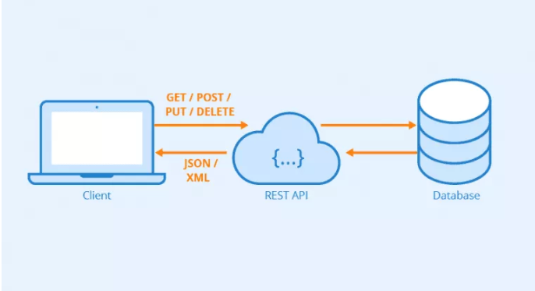

1. **HOW DOES IT WORK : -** REST determines the structure of an API. Developers oblige to a certain set of rules when constructing an API. For instance, one rules states that linking to a URL should return some information.

Every URL is known as a Request, whereas the data returned is known as Response.

REST API breaks a transaction down to generate a sequence of small components. Every component addresses a specific fundamental aspect of a transaction. This modularity makes it a flexible development approach.

A REST API leverages HTTP methods described by the RFC 2616 protocol. (That uses for some request) (*About IETF RFC 2616 -****Hypertext Transfer Protocol -- HTTP/1.1****. The Hypertext Transfer Protocol (HTTP) is an application-level protocol for distributed, collaborative, hypermedia information systems. This specification defines the protocol referred to as "HTTP/1.1"*.)

1. Generally it is the communication between the Client, Resource and Severs.

Ex. When client gives the information about the AIR GO plans tickets are available or not So the third party website like ( PAYTM, AMAZON) gives that information to client. AIR GO give that suitable information about that tickets available or not to that third party website and that third party website send this information to client. This all communication done through REST API.

